LOGO
This Contract is made on 25/05/18 between the Manager: --------- of: ----------
And the practitioner: ----------
(together referred to as “the Parties”).
- Introduction:
This contract sets out the terms and conditions under which the Manager engages the Practitioner to devise and act for ------------------------------------------------.

- Dates Of Engagement:
The Practitioner is engaged under this contract from 29/5/18 until 25/6/18 (though not all the dates are successive, the exact dates being drawn out in the Rehearsal Schedule).

- Financial Provisions:
  - Fee: The Manager shall pay the Practitioner a fee of £1326.00
  - Payment schedule: The fee shall be paid in the following instalments, subject to receipt of invoice from the Practitioner before payment:
1st payment of £326.40 on 1/6/18.
2nd payment of £408 on 8/6/18.
3rd payment of £591.40 on 25/6/18.

  - VAT
    - All payments above are inclusive of VAT if applicable.

- Intellectual Property:
The Practitioner agrees that any Intellectual Property rights that may arise from work that she does for ---------------- under this Contract shall be assigned to ------------------- and shall be the Manager's property in perpetuity.

- Illness:
  - If the Practitioner is unable to complete the services required under the contract due to illness the Practitioner shall be paid for their days’ work up until the point at which they were unable to work.

- Termination:
  - If either Party wishes to terminate this contract before the end date set out in B) above they must give the other Party at least 4 weeks’ written notice.
  - Where this engagement is for a specific project, if the Project is abandoned for reasons beyond the control of the Manager including, but not restricted to: royal demise, national mourning, enemy action, fire, flood, strikes, lockouts or by order of any licensing or other public authority having jurisdiction, this contract ceases to be valid and no further fees or expenses shall be payable to the Practitioner.

- General:
  - The Practitioner will work from his/her own base, using his/her own equipment unless otherwise agreed between the Parties.
  - Nothing in this document shall be read as creating a contract of employment between the Parties.
  - Confidentiality: The Employee agrees not to disclose any confidential information about the work of the Manager, its service users, staff or volunteers, without prior authorisation from the Board.
  - Health and safety: The Manager will take every reasonable step to ensure the Practitioner’s safety, the Practitioner has a legal duty to take reasonable care of his/her own health and safety as well as that of others affected by their acts or omissions.

  - Data Protection: For the purposes of administration it is necessary for the company to hold and sometimes disclose certain personal data about contractors.
    - Any data the company holds about the Practitioner will only be held for so long as the Practitioner works for the Manager, unless the Manager is required to hold it for longer in order to comply with the law. The Manager shall take every care to ensure personal data is held securely and in confidence.
    - The Practitioner has the right to inspect data that the Manager holds about the Practitioner and, if necessary, update that data. Normally inspection of files can be done within 5 working days of a request.
    - If the Practitioner’s personal information changes at any time, the Practitioner should inform the Artistic Director as soon as possible to ensure that the information remains accurate.
  - Severability: If any term or other provision of this Agreement is determined to be invalid, illegal or incapable of being enforced by any rule or law, or public policy, all other conditions and provisions of this Agreement shall nevertheless remain in full force and effect.
  - Third parties:
    - No one apart from the parties to this Agreement can enforce any part of this Agreement.
    - This Agreement may not be assigned to a Third Party by either party.
  - Dispute Resolution & Jurisdiction:
    - If any dispute arises in connection with this agreement, its use or meaning or about its application, it shall, if the parties are unable to agree having followed any applicable internal procedure, be referred to a single mediator to be appointed by the Independent Theatre Council.
    - The governing substantive law of this contract shall be the law of England and the courts of England shall have sole jurisdiction if mediation does not resolve a dispute.

Signed 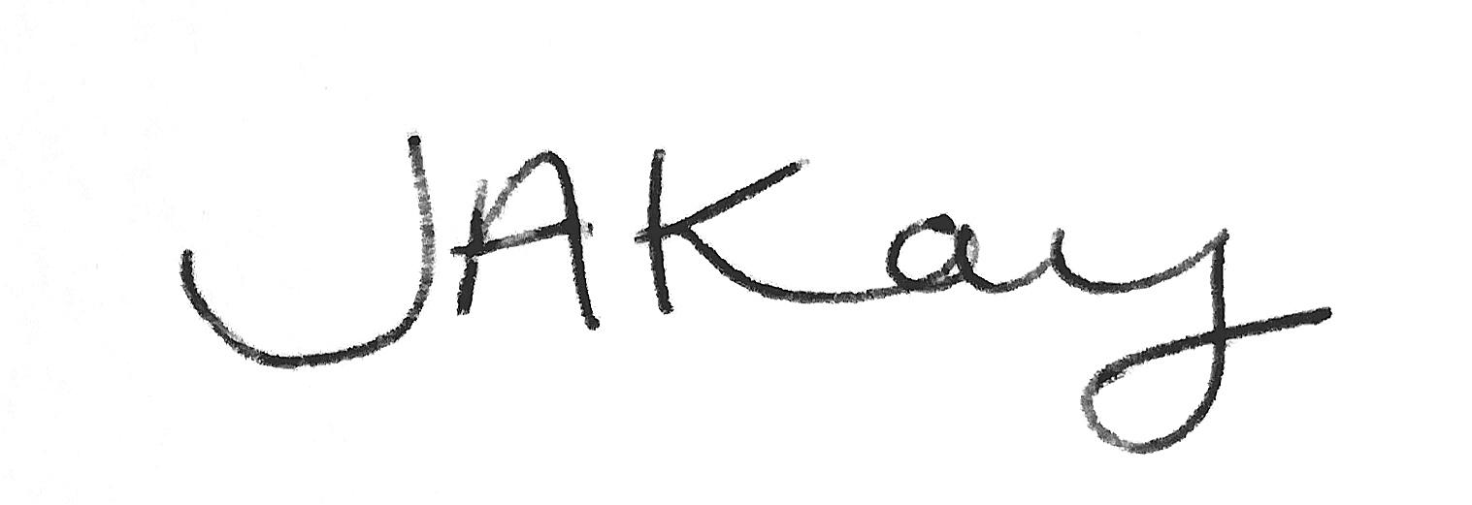
Date 25/05/18

Signed: -------------------
Date 19/5/18
For The Company

